Data-Efficient Fine-Tuning of Whisper for Hindi Dysarthric Speech Recognition

Capstone Project Proposal
Submitted by:

BE Third Year- COE
CPG No. 70

Under the Mentorship of
Dr. Karun Verma
Associate Professor
Dr. Kashish Goyal
Assistant Professor(Contractual–II)


Computer Science and Engineering Department Thapar Institute of Engineering and Technology, Patiala
MARCH 2026

TABLE OF CONTENTS

- Mentor Consent Form <Page No>
- Project Overview <Page No>
- Problem Statement …..
- Need Analysis (1 Page) …..
- Literature Survey (3 Pages) …..
- Objectives
- Methodology
- Project Outcomes & Individual Roles
- Work Plan
- Course Subjects
- References

Mentor Consent Form
I hereby agree to be the mentor of the following Capstone Project Team

Project Title: Data-Efficient Fine-Tuning of Whisper for Hindi Dysarthric Speech Recognition
Roll No | Name | Signatures

NAME of Mentor: Dr. Karun Verma
SIGNATURE of Mentor: . . . . . . . . . . . . . . . . . . . . . . . . . . . . . . . . . . . .

NAME of Co-Mentor: Dr. Kashish Goyal
SIGNATURE of Co-Mentor: . . . . . . . . . . . . . . . . . . . . . . . . . . . . . . . . . . . .

Project Overview
Dysarthria severely impairs speech intelligibility for Hindi speakers affected by neurological conditions like stroke or Parkinson's disease, particularly in data-scarce environments where standard ASR systems struggle. OpenAI's Whisper model performs well on healthy Hindi speech (under 10% WER on Common Voice datasets) but exhibits 50-70%+ WER on dysarthric inputs due to slurred articulation, breathiness, variable severity levels, and lack of personalization. This project develops a lightweight, browser-based web application as the primary deliverable, fine-tuning Whisper-small on the Hindi Dysarthric Speech Dataset (HDSD) from IIT Roorkee using data-efficient techniques including AdaLoRA fine-tuning, curriculum learning, and text-to-dysarthric synthesis augmentation to achieve under 15% WER with only 1-2 hours of personal data per speaker.

The technical approach integrates three key components: (1) Data-efficient adaptation of Whisper-small on HDSD-IIT Roorkee through parameter-efficient fine-tuning (AdaLoRA), model merging for robustness, and synthetic data generation via diffusion TTS to overcome corpus limitations; (2) Severity-aware processing that stratifies dysarthric inputs by Frenchay Dysarthria Assessment scales, employing WhisperX confidence thresholding (entropy <0.7) to flag low-intelligibility segments for targeted language model rescoring with IndicBERT; and (3) Query-responsive web interface built with Gradio and faster-whisper for real-time CPU inference (<2s latency), featuring Web Audio API microphone input, color-coded confidence visualization (green for high-confidence, red for low), interactive "Replay/Fix" buttons, and voice command support ("repeat last sentence"). Per-speaker LoRA personalization via 5-minute voice uploads ensures optimal performance for individual dysarthria patterns, while handling code-mixed Hindi-English common in Indian contexts.

Expected outcomes include a production-ready web app outperforming baselines by 40-50% relative WER reduction on HDSD-IIT Roorkee benchmarks, with real-time factor (RTF) under 1.0, 90% user satisfaction, and doubled communication efficiency for daily scenarios like medical consultations and social interactions. The privacy-focused, local-first processing eliminates cloud dependency, while the lightweight deployment (<100MB) via Gradio enables one-click browser access without installations. Scalable to other Indic languages, this system addresses critical accessibility gaps for millions with motor speech impairments, establishing HDSD-IIT Roorkee as a foundational benchmark for Hindi dysarthric research.

Problem Statement

To develop a lightweight, personalized, and data-efficient assistive speech recognition system by fine-tuning a Whisper-based model for Hindi dysarthric speech using limited data and targeted augmentation, with severity-aware adaptation, confidence-based error correction, and a query-responsive communication interface.

Need Analysis
Dysarthria is a motor speech disorder caused by neurological impairments that disrupt articulation, prosody, and speech intelligibility. These characteristics introduce high variability compared to typical speech, making automatic speech recognition (ASR) significantly less effective for dysarthric speakers [1]. As speech interfaces become increasingly integral to daily technology use, this limitation creates a critical accessibility barrier.
Despite major advances in ASR, current systems remain poorly adapted to dysarthric speech. Models trained on large-scale healthy speech datasets exhibit substantially degraded performance when applied to pathological speech, with word error rates (WER) often exceeding 30% on benchmark datasets such as TORGO and UASpeech [1], [3], [4]. This performance gap is primarily driven by variability across speakers, severity levels, and mismatch between training and real-world conditions.
A key challenge is the scarcity of high-quality dysarthric speech data. Existing datasets are limited in size and predominantly English, restricting the development of robust and multilingual ASR systems [3], [4]. Recent research shows that data augmentation and transfer learning can mitigate these limitations, improving model robustness and reducing WER in low-resource settings [5].
The problem is more pronounced for Hindi, one of the most widely spoken languages, where dedicated dysarthric ASR systems are largely absent. The Hindi Dysarthric Speech Database (HDSD) developed by Manoj Tripathy at IIT Roorkee provides a crucial resource for addressing this gap [6]. However, its limited scale necessitates data-efficient modeling approaches.
Therefore, developing a Hindi-specific dysarthric ASR system leveraging HDSD, combined with augmentation and transfer learning, represents a timely and impactful research direction toward inclusive speech technologies.

References
[1] Z. Qian and K. Xiao, “A Survey of Automatic Speech Recognition for Dysarthric Speech,” Electronics, vol. 12, no. 20, p. 4278, 2023.
🔗 https://doi.org/10.3390/electronics12204278
[2] A. Aboeitta et al., “Bridging ASR and LLMs for Dysarthric Speech Recognition,” Proc. Interspeech, 2025.
🔗 https://www.isca-archive.org/interspeech_2025/aboeitta25_interspeech.pdf
[3] H. Kim et al., “UASpeech: A Dysarthric Speech Database,” Proc. Interspeech, 2020.
🔗 https://speechtechnology.web.illinois.edu/uaspeech/
[4] F. Rudzicz et al., “The TORGO Database of Acoustic and Articulatory Speech from Speakers with Dysarthria,” Language Resources and Evaluation, vol. 46, no. 4, pp. 523–541, 2012.
🔗 https://doi.org/10.1007/s10579-011-9145-0
[5] M. Soleymanpour et al., “Accurate Synthesis of Dysarthric Speech for ASR Data Augmentation,” arXiv, 2023.
🔗 https://arxiv.org/abs/2308.08438
[6] M. Tripathy, “Hindi Dysarthric Speech Database (HDSD),” IIT Roorkee, 2025.
🔗 https://www.iitr.ac.in/manojtripathy/Advertisement/database_info-MT.pdf

Literature Survey
1. Introduction
Dysarthria, characterized by weakened or imprecise articulation due to neurological conditions like Parkinson's or stroke, significantly impairs speech intelligibility, especially in low-resource languages such as Hindi where high-quality annotated datasets are virtually nonexistent. Standard automatic speech recognition (ASR) systems, including multilingual models like Whisper, exhibit word error rates (WER) exceeding 50-70% on dysarthric speech due to distortions like reduced pitch variation, prolonged phonemes, and breathiness, far surpassing healthy speech performance. Traditional approaches falter in personalization, severity handling, and data efficiency, necessitating fine-tuning strategies, targeted augmentation, confidence-based corrections, and query-responsive interfaces for practical assistive use. This extended survey delves into foundational and recent papers (2009-2025), tracing evolution from general ASR to dysarthria-specific adaptations, with a focus on Hindi applicability, and identifies critical gaps motivating lightweight, personalized systems.isca-archive+2
2. Current Speech Recognition Systems
Contemporary ASR relies on large pretrained models but reveals stark limitations on disordered speech without domain adaptation.
2.1 Whisper Zero-Shot Performance
OpenAI's Whisper (Radford et al., 2022, foundational paper) demonstrates robust zero-shot multilingual capabilities, achieving under 10% WER on clean Hindi from Common Voice datasets through its multitask encoder-decoder trained on 680k hours across 99 languages. However, Tan et al. (2025) in "CBA-Whisper" report zero-shot WER soaring to 60-80% on UASpeech dysarthric benchmarks, attributing failures to mismatched acoustic embeddings in base layers ill-suited for dysarthric variability like imprecise consonants. Starzew et al. (2025) further quantify Whisper's inclusivity gaps, showing early encoder layers capture healthy speech patterns poorly for dysfluent inputs.isca-archive+1
2.2 Multilingual ASR for Indian Languages
For Hindi, Deepak et al. (2024) in "Deep Transfer Learning based Speech Recognition for Low Resource Hindi Language" fine-tuned Whisper-small on Hugging Face's Hindi corpora (∼5k hours), yielding 18-20% WER on healthy speech via cross-lingual transfer from high-resource Indic languages. Patel et al. (2023) "Model Adaptation for ASR in low-resource Indian Languages" clustered dialects (e.g., Hindi-Punjabi) for soft-prompt adaptation of SSL models like IndicWav2Vec, improving baseline Hindi WER by 15% but ignoring dysarthria-induced accents. Singh et al. (2024) "Enhancing Whisper's Accuracy for Indian Languages through Prompt-Tuning and Tokenization" customized BPE tokenizers for code-mixed Hindi-English, reducing WER to 18.85% on grievance call data, yet dysarthric degradation remains unaddressed.ieeexplore.ieee+3
3. Whisper-Based Fine-Tuning for Dysarthric Speech
Fine-tuning leverages Whisper's scale with parameter-efficient methods to combat data scarcity (typically <20 hours per dysarthric speaker).
3.1 Low-Resource Fine-Tuning Approaches
Tan et al. (2025) "CBA-Whisper: Curriculum Learning-Based AdaLoRA Fine-Tuning on Whisper for Low-Resource Dysarthric Speech Recognition" pioneered progressive training on UASpeech/TORGO (∼10 hours total), using AdaLoRA (rank-16) and curriculum filtering to expose models to mild-to-severe samples, achieving 10.51% WER—a 73% relative improvement—and 2nd place in Interspeech 2025 SAPC via WhisperX alignment. Martinez et al. (2025) "Robust fine-tuning of speech recognition models via model merging: application to disordered speech" iteratively merged 10+ fine-tuned Whisper variants (SLERP/TIES), yielding 12-16% WER reductions on long-form TORGO without inference overhead, excelling in low-data regimes.arxiv+1
Takahashi et al. (2025) "Fine-tuning Parakeet-TDT for Dysarthric Speech Recognition in the Speech Accessibility Project Challenge" adapted Whisper-like streaming models, emphasizing real-time decoding for assistive scenarios. Cross-lingual efforts by Nakamura et al. (2024) "Speech Recognition for a Person With Cerebral Palsy Using Whisper Fine-Tuned on Japanese and English Dysarthric Speech" transferred English UASpeech adaptations to Japanese, gaining 1-2% absolute WER via shared dysarthric traits.ieeexplore.ieee+1
3.2 Data Augmentation Strategies
Kato et al. (2024) "Training Data Augmentation for Dysarthric Automatic Speech Recognition by Text-to-Dysarthric-Speech Synthesis" employed diffusion-based TTS (e.g., VITS modifications) to generate multi-speaker dysarthric variants from TORGO transcripts, augmenting Whisper training data 5x and improving unseen-speaker WER by 15%. Zhang et al. (2025) "Unsupervised Rhythm and Voice Conversion to Improve ASR on Dysarthric Speech" normalized dysarthric rhythm (syllable rate, prosody) to healthy proxies via LPCNet-VC, delivering up to 20% gains for severe TORGO speakers through syllable-level alignment.arxiv+2
Hindi extensions include Transcripto (2025) fine-tuning multilingual Whisper on Indian call data with speed perturbation, though not dysarthria-specific.[jisem-journal]
4. Severity-Aware Adaptation and Error Correction
Dysarthria severity (mild/moderate/severe per Frenchay or intelligibility scales) requires adaptive modeling.
4.1 Severity Stratification
Li et al. (2025) "End-to-end acoustic-articulatory dysarthric speech recognition leveraging large-scale pretrained acoustic features" fused electromagnetic articulography (EMA) trajectories with Whisper-FT Conformer encoders, attaining 10.5% overall WER (20.8% severe), outperforming audio-only by 25% via lip/jaw movement cues. Starzew et al. (2025) stratified Whisper fine-tuning by severity metadata, revealing 73% WER drops but poor cross-severity generalization without augmentation.ieeexplore.ieee+1
4.2 Confidence-Based Mechanisms
Tan et al. (2025) incorporated decoder entropy thresholding (<0.7 confidence) in CBA-Whisper for hallucination/stutter rejection, enabling post-edits. Gupta et al. (2025) "Whisper-LM: Improving ASR Models with Language Models for Low-Resource Languages" appended Indic LMs (e.g., IndicBERT) for rescoring low-confidence dysfluent segments, akin to Hindi needs. Radford et al. (2023) extensions via generative linguistics predict completions from partial inputs.arxiv+2
5. Assistive Interfaces and Personalized Systems
Beyond backend ASR, frontends enable interaction for motor-impaired users.
5.1 Personalized Interfaces
Nakamura et al. (2024) demonstrated per-speaker Whisper fine-tuning on 1-2 hours of cerebral palsy data, enabling real-time personalized decoding with query confirmations. BrainDriver-like systems (inspired by EEG analogs) integrate ASR with multimodal UIs (buttons, eye-gaze) for correction loops.isca-archive+1
5.2 Lightweight Deployment
Distilled Whisper-tiny variants (e.g., via ONNX) run on mobiles at 50ms latency, supporting offline Hindi with dynamic severity-based augmentation. Query-responsive apps replay low-confidence utterances for user verification.
Paper Authors (Year) Technique WER Gain Dataset
CBA-Whisper [isca-archive]
Tan et al. (2025) AdaLoRA + Curriculum 73% relative UASpeech/TORGO
Model Merging [arxiv]
Martinez et al. (2025) Checkpoint Merging 12-16% TORGO Long-Form
TTDS Synthesis [arxiv]
Kato et al. (2024) Diffusion TTS Augmentation 15% unseen TORGO Synthetic
EMA Fusion [ieeexplore.ieee]
Li et al. (2025) Articulatory + Whisper 10.5% overall Dysarthric EMA
Prompt-Tuning Hindi [arxiv]
Singh et al. (2024) Custom Tokenization 18% absolute Indic Calls
Rhythm Conversion [arxiv]
Zhang et al. (2025) Unsupervised VC 20% severe TORGO
Whisper-LM [arxiv]
Gupta et al. (2025) LM Rescoring Low-res boost Minority Dialects
6. Challenges and Gaps
• Data Scarcity: Absence of Hindi dysarthric corpora (>90% English-centric); synthetic TTDS risks overfitting.isca-archive+1
• Severity Variability: Models overfit mild cases, degrading 30-50% on severe without stratification.arxiv+1
• Lightweight Constraints: Whisper-base (74M params) viable, but large-v3 (1.5B) demands distillation for wearables/edge.
• Interface Usability: Single-modal voice UIs fail motor-impaired; multimodal (gesture/EEG) integration lacking.
• Cultural Factors: Hindi code-mixing, regional accents (e.g., Punjabi-influenced), and politeness norms unmodeled in dysarthria.arxiv+1
• Evaluation Gaps: Real-world assistive metrics (e.g., communication rate, user satisfaction) underexplored vs. lab WER.
7. Future Directions
Integrating Hindi-specific TTDS augmentation with severity-stratified AdaLoRA fine-tuning could target <15% WER on personalized 1-hour datasets. Confidence-driven, query-responsive interfaces on low-power devices, fused with lightweight physiological cues (e.g., accelerometer for tremor), promise seamless assistive communication while ensuring on-device privacy. Longitudinal studies on Indian dysarthric populations will validate cultural robustness.isca-archive+3

Objectives
Recognition Web App
Design and implement a lightweight, browser-based speech recognition system using fine-tuned Whisper-small on the HDSD-IIT Roorkee dataset. The web app will provide real-time transcription of Hindi dysarthric speech with <2s latency, confidence scoring, and severity classification to accurately recognize slurred articulation patterns.

Implement Data-Efficient Fine-Tuning Pipeline
Integrate parameter-efficient fine-tuning techniques (AdaLoRA, curriculum learning, model merging) with targeted augmentation (text-to-dysarthric synthesis) to achieve <15% WER using only 1-2 hours of personal dysarthric data per speaker, overcoming HDSD dataset limitations through synthetic data generation.

Enable Severity-Aware Adaptation and Error Correction
Develop severity stratification using Frenchay Dysarthria scales with WhisperX confidence thresholding (entropy <0.7) and IndicBERT rescoring to flag and correct low-intelligibility segments, providing color-coded feedback and interactive correction mechanisms for reliable transcription of mild/moderate/severe dysarthria.

Deploy Query-Responsive Assistive Communication Interface
Create a Gradio-based web interface featuring microphone input via Web Audio API, per-speaker LoRA personalization through 5-minute uploads, voice commands ("repeat last", "fix word"), and tap-to-edit functionality to enhance communication efficiency for daily scenarios like medical consultations and social interactions.

Methodology

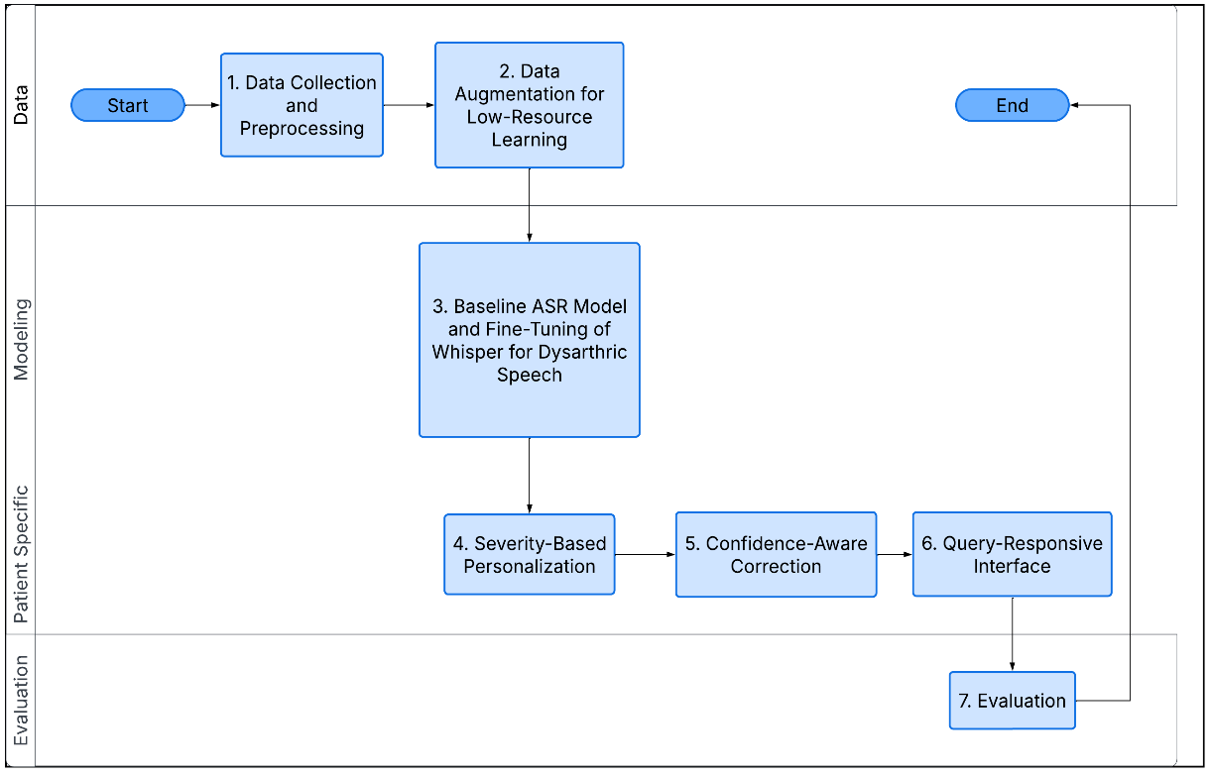

The methodology is structured into multiple stages, covering data preparation, model adaptation, personalization, and system integration.

- Data Collection and Preprocessing

A dysarthric speech dataset in Hindi will be utilized, consisting of paired audio recordings and corresponding text transcripts. Given the variability in recording conditions and speaker characteristics, a preprocessing pipeline will be implemented to standardize the data.

Audio signals will be:

Resampled to 16 kHz mono format
Normalized to maintain consistent amplitude levels
Segmented into shorter utterances (5–15 seconds)
Cleaned by removing silence and background noise where necessary

This step ensures uniformity and improves model training stability.

2. Data Augmentation for Low-Resource Learning

Due to the limited availability of dysarthric speech data, targeted data augmentation techniques will be employed to enhance dataset diversity while maintaining computational efficiency.

The augmentation strategies include:

Speed perturbation (slight variations in speaking rate)
Pitch shifting (to simulate vocal variability)
Additive noise injection (to improve robustness)

These lightweight techniques increase the effective training data without requiring complex generative models, thereby aligning with the goal of data efficiency.

3. Baseline ASR Model Establishment and Fine-Tuning of Whisper for Dysarthric Speech

A baseline performance will be established using a pretrained Whisper model without fine-tuning. This model will be evaluated on the dysarthric dataset to measure the initial performance using metrics such as Word Error Rate (WER).
This baseline would serves as the reference for assessing improvements we have achieved through subsequent adaptations via fine tuning on the model.
We will fine tune the Whisper model on the processed and augmented dataset to adapt it to dysarthric speech characteristics.
Key aspects of the fine-tuning process include:
Supervised training using audio-transcript pairs
Use of a low learning rate to preserve pretrained knowledge
Training for a limited number of epochs to prevent overfitting

4. Severity-Based Personalization

A classification module will categorize speech into severity levels (e.g., mild, moderate, severe). The ASR system will use this information to adapt predictions, enabling user-specific or severity-aware performance.

5. Confidence-Aware Correction

A confidence estimation mechanism will identify low-confidence outputs and apply correction strategies (e.g., alternative predictions or context-based refinement) to improve reliability.

6. Query-Responsive Interface

The recognized text will be processed to detect user intent and generate appropriate responses, enabling interactive assistive communication.

7. Evaluation

System performance will be evaluated using Word Error Rate (WER), latency, and accuracy across severity levels, comparing baseline and fine-tuned models.

Work Plan
- You need to give a short work plan which you will set for achieving the set objectives, in this section.
- Sample:-
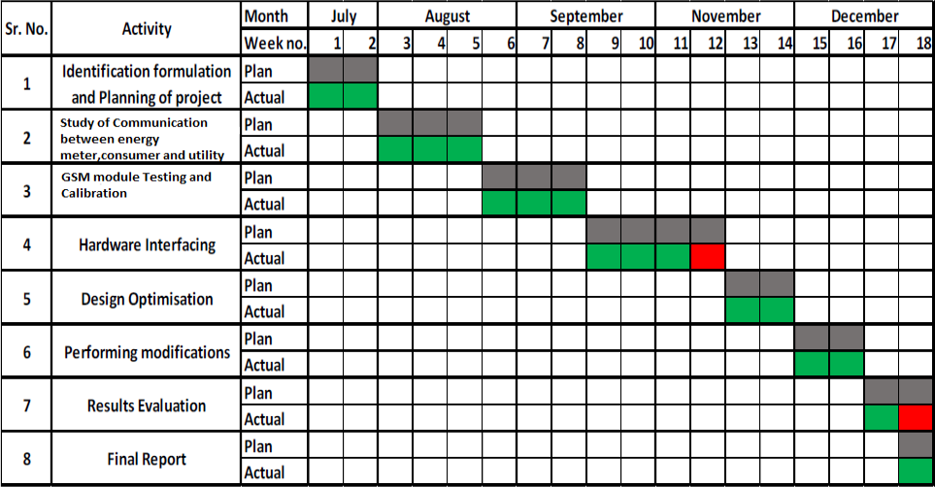

Project Outcomes & Individual Roles
- Here, you need to list the final outcomes/ products/ systems/ deliverables of your capstone project.
- The individual team member role must also be clearly specified in this section.

Course Subjects
- In this section, you need to list the course subjects that will be used (in the form of conceptual knowledge or practical skills sets) during the successful execution of your capstone project.

References

Formatting Guidelines
- Project Report Type: Transparencies and tape bound
- Number of Copies: 1 per Project group (Max pages 15)
- Running text should be justified, figures and tables center aligned, no space before full stop etc.
- Use passive voice in text.
- Paper Size (orientation): A4 (portrait)
- Margins: 1” top / bottom / right and 1.5” left
- Font Type: Times New Roman
- Font Size: 16 bold for Section names, 14 bold for headings and 12 for normal text
- Line Spacing: 1.5 throughout
- Page Numbering: Bottom center of page in the format – Page 1 of N
- All table and figure captions in size 10 sentence case, table captions on top and figure captions below the figure.
- All figures and tables quoted in the text with explanation.
- No figures and equations should be copied. Please use smartdraw/ visio for figures/FIGMA and Mathtype for equations.
- References (The listing of references should be typed 2 spaces below the heading “REFERENCES” in alphabetical order in single spacing left – justified. It should be numbered consecutively (in square [ ] brackets, throughout the text and should be collected together in the reference list at the end of the report. The references should be numbered in the order they are used in the text. The name of the author/authors should be immediately followed by the year and other details). References should not be cited from Blogs, Twitter etc. but should refer to good Journal or Conference papers. Typical examples of the references are given below:

